FIFO PROBLEM STATEMENT

1a)SYNCHRONUS FIFO :
`timescale 1ns/1ps
module sync_fifo #(
parameter DATA_WIDTH = 8,
parameter DEPTH = 16,
parameter PROG_FULL_THRESH = DEPTH - 4,
parameter PROG_EMPTY_THRESH = 4
)(
input clk,
input rst_n,

input wr_en,
input rd_en,

input [DATA_WIDTH-1:0] wr_data,
output reg [DATA_WIDTH-1:0] rd_data,

output full,
output empty,
output almost_full,
output almost_empty,
output prog_full,
output prog_empty
);

localparam ADDR_WIDTH =
(DEPTH <= 1) ? 1 : $clog2(DEPTH);

localparam COUNT_WIDTH =
(DEPTH <= 1) ? 1 : $clog2(DEPTH + 1);

// FIFO Memory

reg [DATA_WIDTH-1:0] mem [0:DEPTH-1];
// Pointers and Occupancy Counter

reg [ADDR_WIDTH-1:0] wr_ptr;
reg [ADDR_WIDTH-1:0] rd_ptr;

reg [COUNT_WIDTH-1:0] count;
// Accepted Read / Write Operations

wire do_write;
wire do_read;

assign do_write = wr_en && !full;
assign do_read = rd_en && !empty;

// Status Flags

assign empty = (count == 0);
assign full = (count == DEPTH);

assign almost_empty = (count == 1);
assign almost_full = (count == DEPTH - 1);

assign prog_empty = (count <= PROG_EMPTY_THRESH);
assign prog_full = (count >= PROG_FULL_THRESH);

// Write Logic

always @(posedge clk or negedge rst_n) begin

if (!rst_n) begin
wr_ptr <= 0;
end

else if (do_write) begin

mem[wr_ptr] <= wr_data;

if (wr_ptr == DEPTH - 1)
wr_ptr <= 0;
else
wr_ptr <= wr_ptr + 1'b1;

end
end
// Read Logic

always @(posedge clk or negedge rst_n) begin

if (!rst_n) begin
rd_ptr <= 0;
rd_data <= 0;
end

else if (do_read) begin

rd_data <= mem[rd_ptr];

if (rd_ptr == DEPTH - 1)
rd_ptr <= 0;
else
rd_ptr <= rd_ptr + 1'b1;

end
end
// Occupancy Counter

always @(posedge clk or negedge rst_n) begin

if (!rst_n) begin
count <= 0;
end

else begin

case ({do_write, do_read})

2'b10: begin
// Write only
count <= count + 1'b1;
end

2'b01: begin
// Read only
count <= count - 1'b1;
end

2'b11: begin
// Simultaneous read and write
count <= count;
end

2'b00: begin
// No operation
count <= count;
end

endcase
end
end

endmodule

WAVEFORM :-
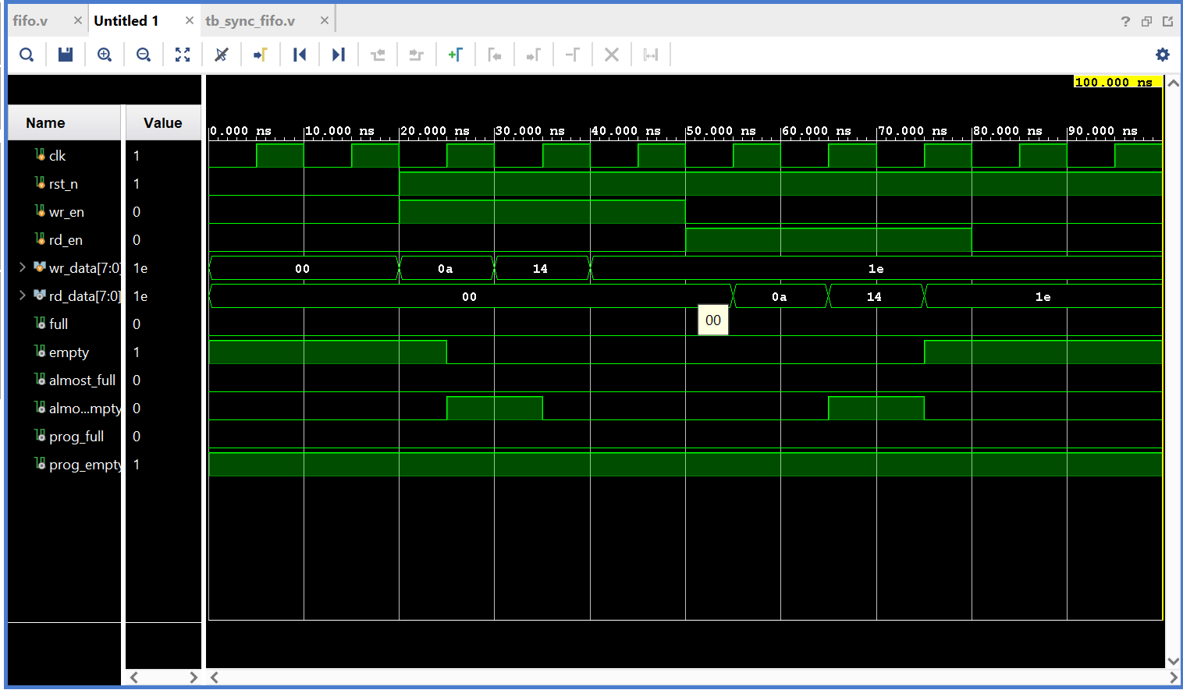

1b) Test case 2 : In this test case, we continuously write data into the FIFO until it becomes full.
We check how the FIFO status flags change as the number of stored data words increases:
- prog_full becomes 1 when the FIFO count reaches the programmed threshold of 12.
- almost_full becomes 1 when the FIFO has 15 stored words.
- full becomes 1 when all 16 locations are filled.
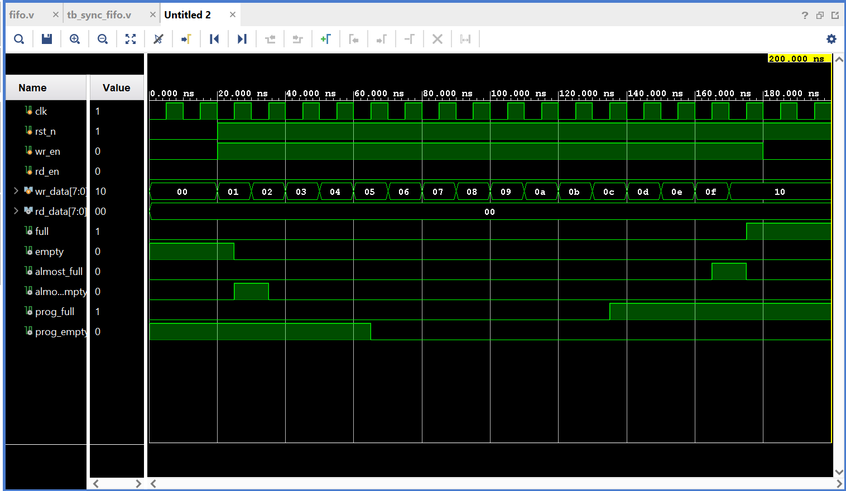

1c) Test Case 1C - Empty and Programmable Empty Flag Verification :
In this test case, five data values (10, 20, 30, 40, 50) are written into the FIFO and then read sequentially. As the FIFO occupancy decreases, the prog_empty flag becomes HIGH when the count reaches the programmed threshold of 4 or less. The almost_empty flag becomes HIGH when only one data word remains, and the empty flag becomes HIGH when all the data has been read.
Waveform Observation: The waveform shows the data being written and read in the same order. The prog_empty, almost_empty, and empty flags are asserted at their respective conditions, verifying the correct empty-side status indication.
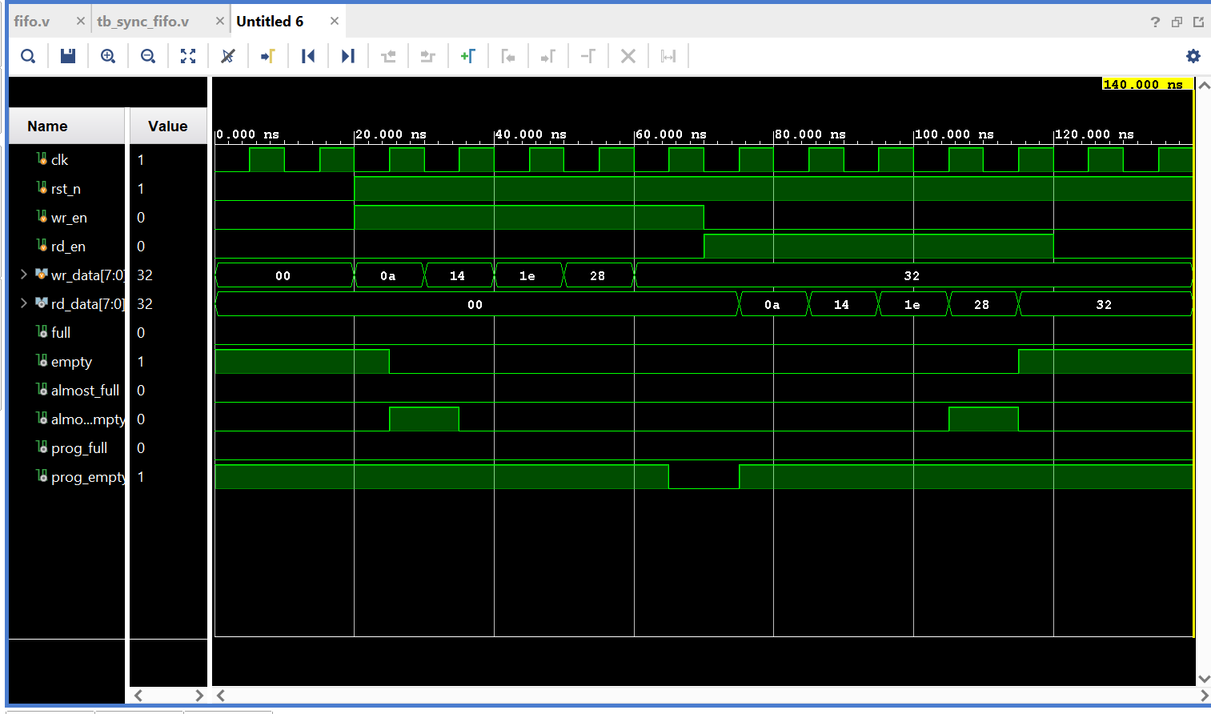

1d)Test case 1D - In this test case, the FIFO is first filled with 16 data values from 00 to 0F. Once the FIFO becomes full, an additional write operation is attempted. Since the full flag is HIGH, the additional data is not accepted. The FIFO is then read sequentially until all 16 data values are removed. Finally, an additional read operation is attempted when the FIFO is empty.
The waveform shows the data being written from 00 to 0F and the full flag becoming HIGH when the FIFO reaches its maximum depth. The extra write operation with data 64 is not accepted. During the read operation, the stored data is read sequentially and the empty flag becomes HIGH after the last data is read. The additional read operation while the FIFO is empty is not accepted.
